**Software Engineering for AI Enabled Systems Lab**

**Assignment 1 - Version Control Tools- Git and Github**

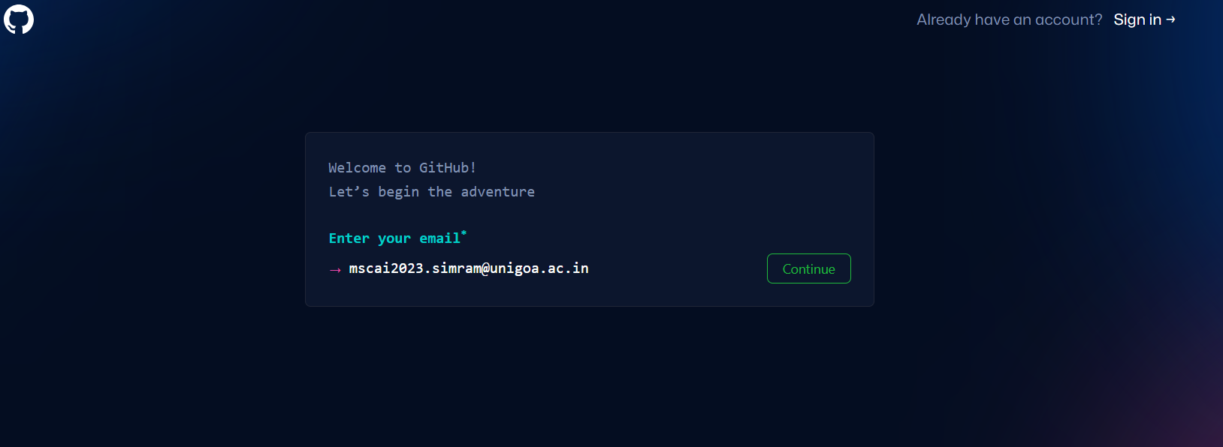

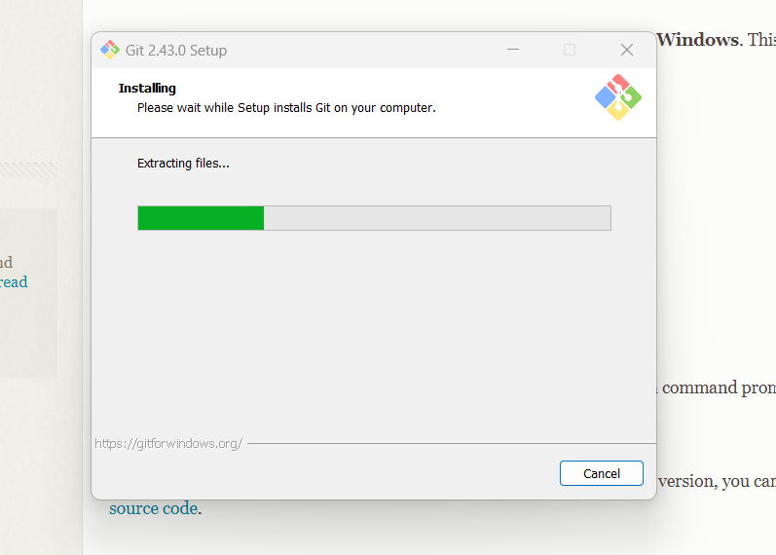

**GIT BASH**

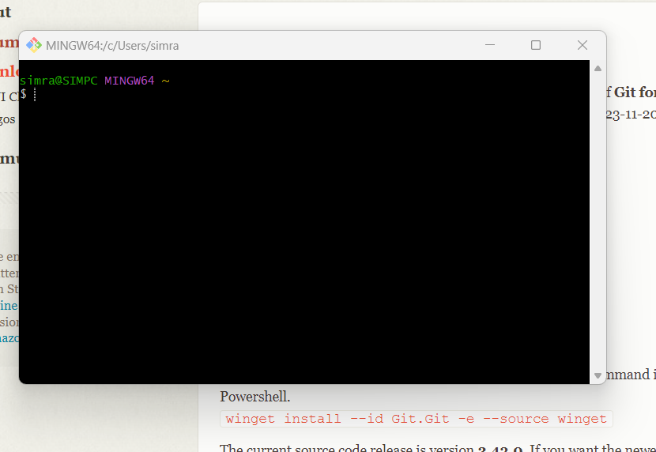

**Creating new repository**

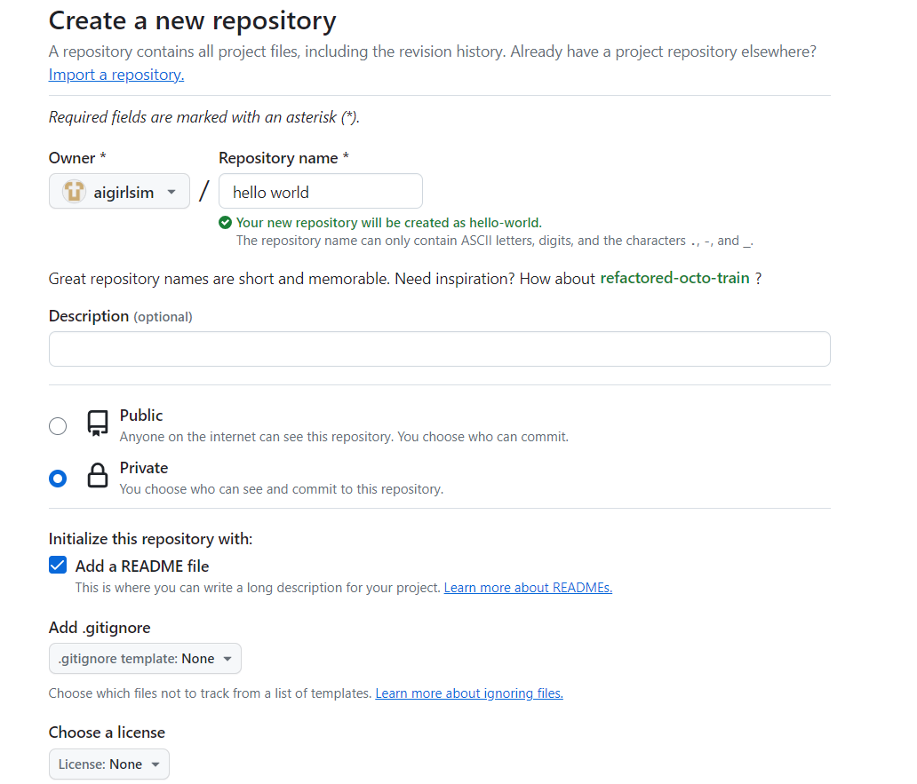

**Repository with name hello-world**

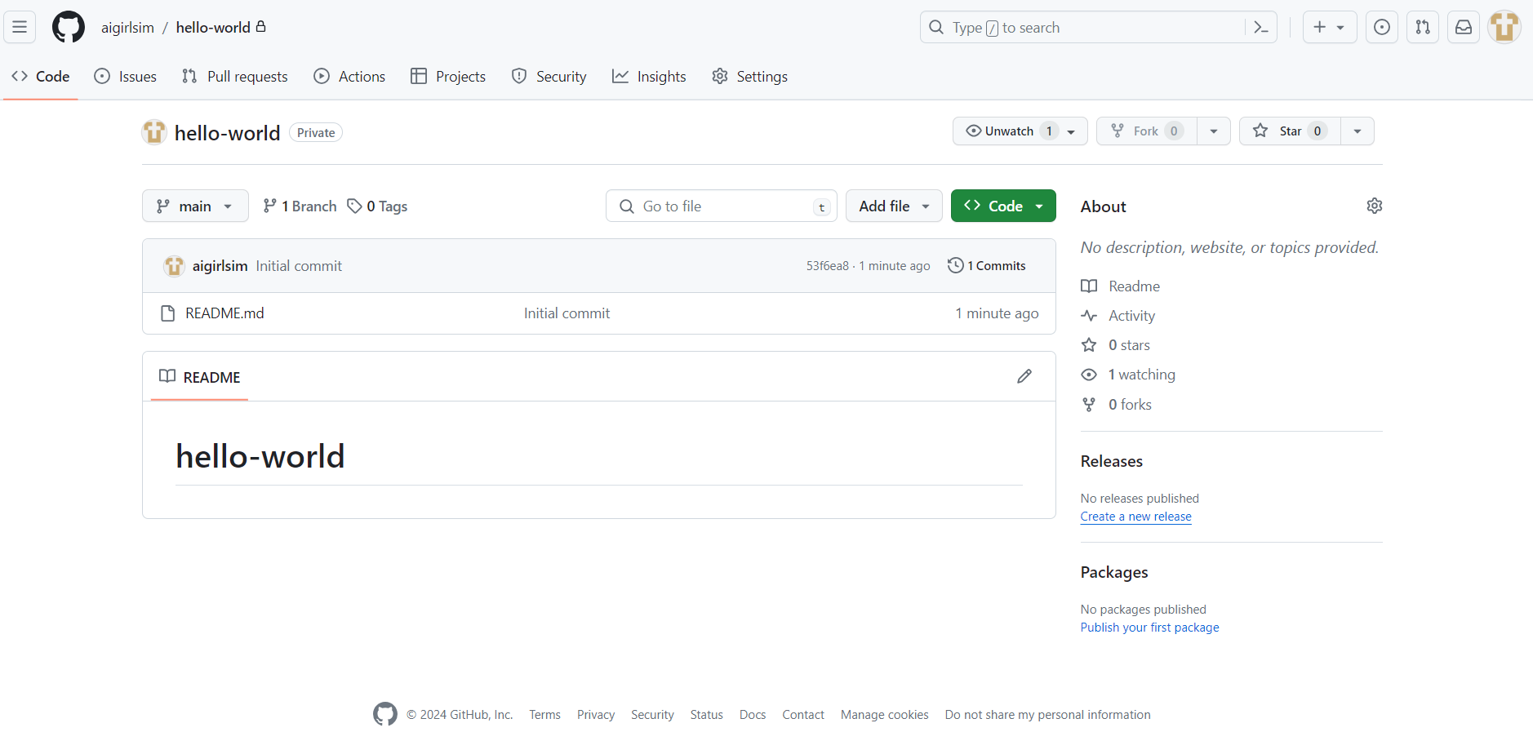

**Different Branch inside main with name edit-change**

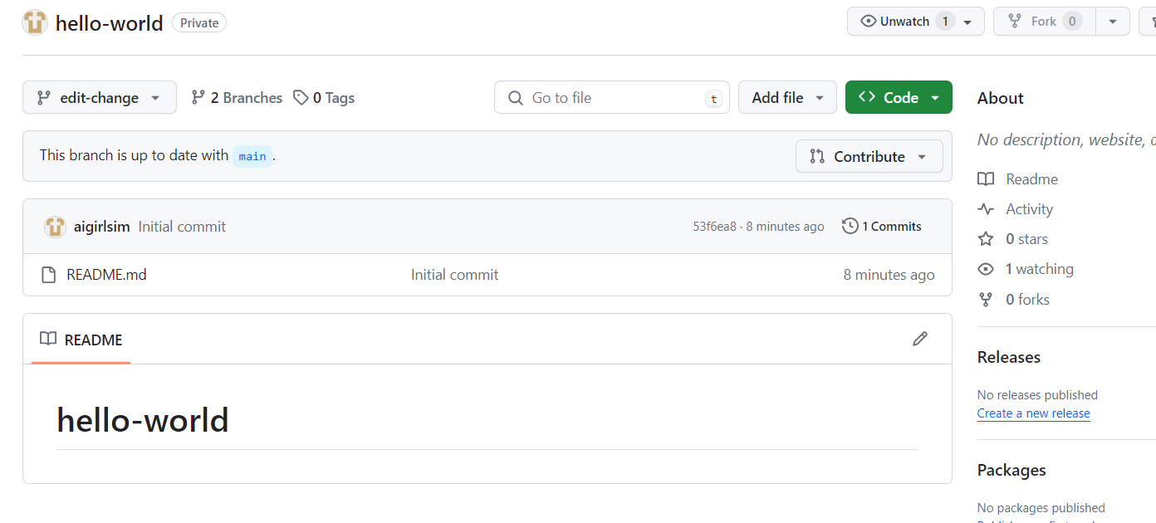

**This is README.md*file* before Commit change**

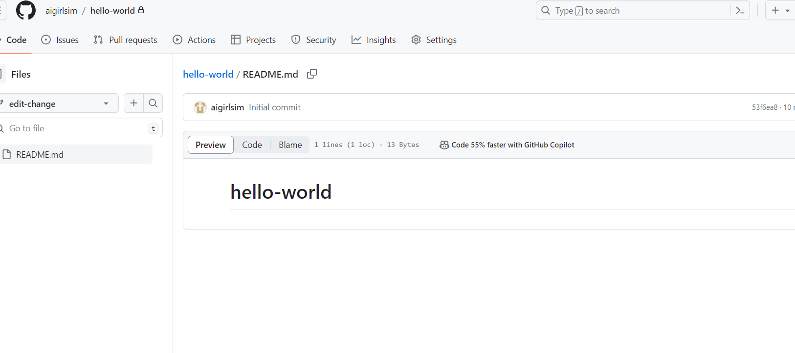

**Before commit any change**

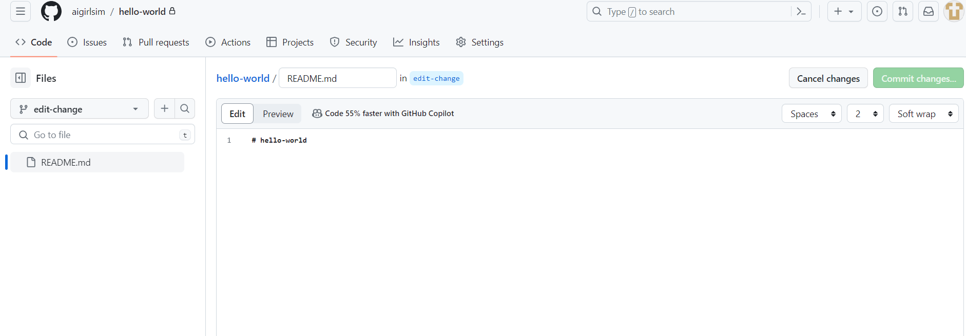

**During Commit changes**

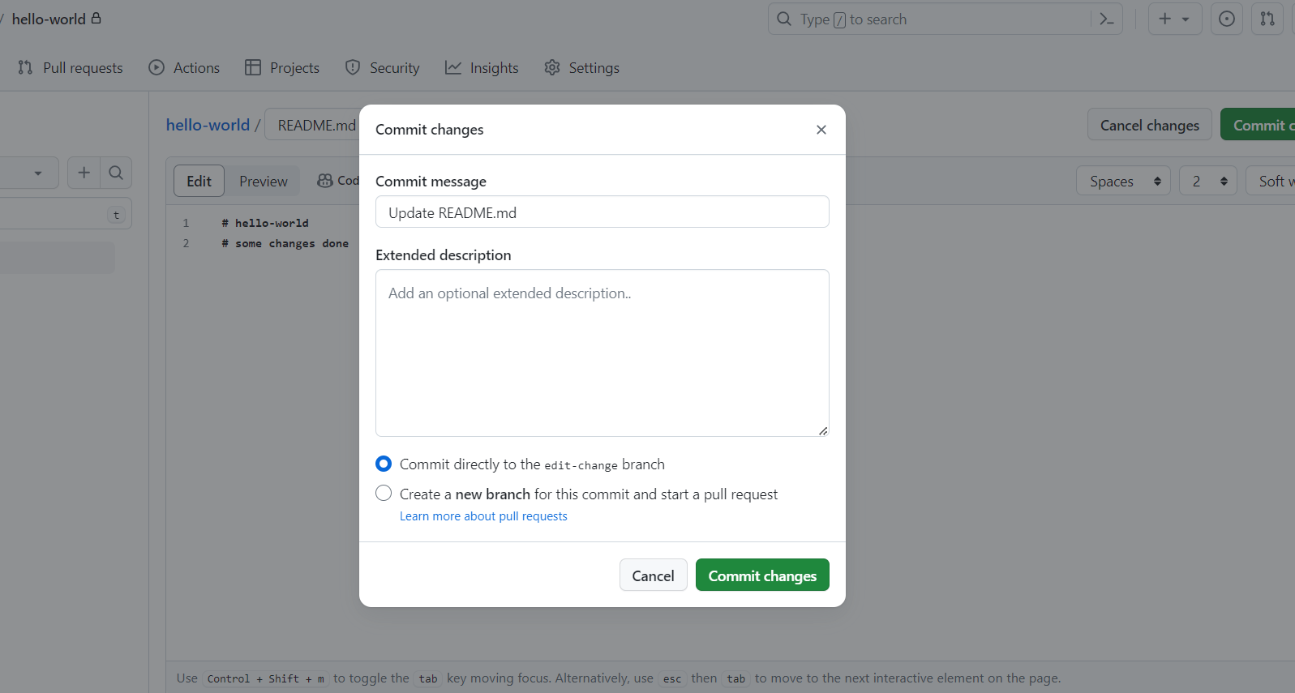

**After Commit changes**

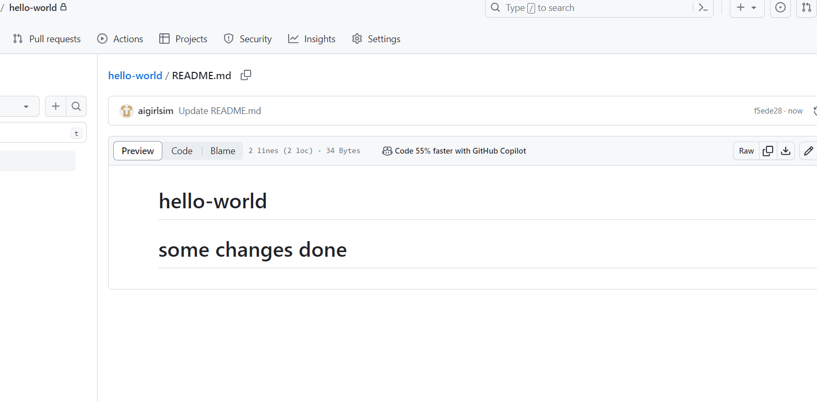

**Comparison of all changes done on file**

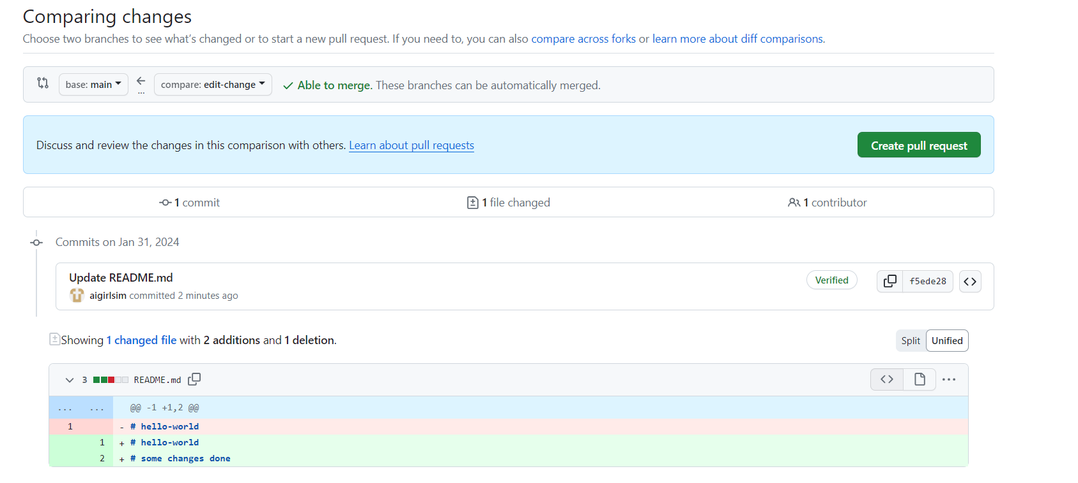

**GIT COMMMANDS**

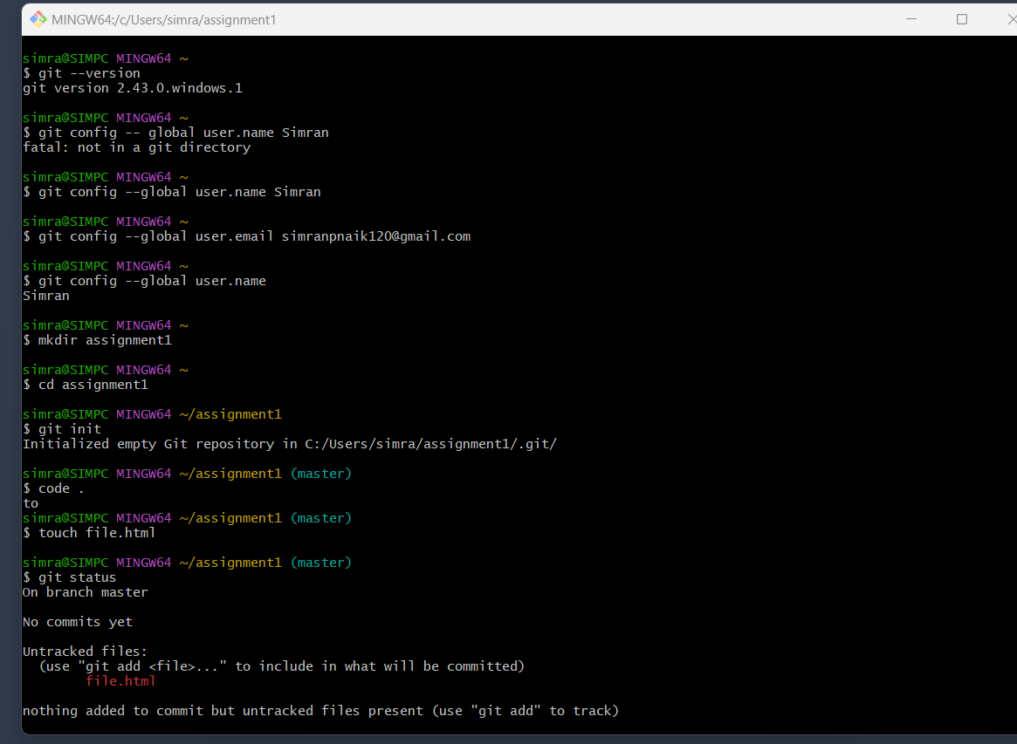

**Example of git commands**

1. **git –version**
2. **git config**
3. **git commit**
4. **git diff**
5. **git add**
6. **git checkout**
7. **git merge**
8. **git reset**
9. **git status**
10. **git rm**
11. **git log**
12. **git show**
13. **git tag**
14. **git branch**
15. **git remote**
16. **git pull**
17. **git push**
18. **git tag**
19. **git clone**